Assignment lab8

Question 1 (code)

#include <iostream>

using namespace std ;

int main ()

{

int size;

cout<<"Enter the size of array:"<<endl;

cin>>size;

int array[size];

for(int i=0; i<size; i++ ){

cout<<"Enter value number" <<i+1<<":";

cin>>array[i];

cout<<endl;

}

cout<<"The numbers in reverse order are:"<<endl;

for(int j=size-1; j>=0; j--){

cout<<array[j]<<" ";

}

return 0;

}

Question 1 (output)

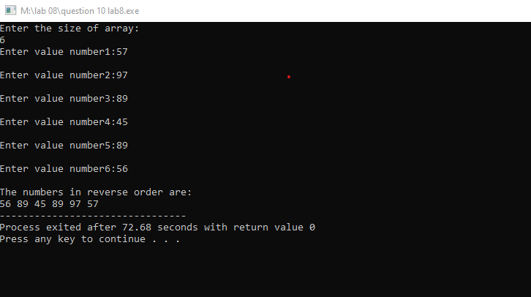

Question 2 (code)

#include <iostream>

using namespace std ;

int main ()

{

int size;

cout<<"Enter the size of array:";

cin>>size;

int array[size],sum(0);

for(int i=0; i<size; i++){

cout<<"Enter the value of number"<<i+1<<":";

cin>>array[i];

sum=sum+array[i];

}

cout<<"Sum="<<sum<<endl;

return 0;

}

Question 2 (output)

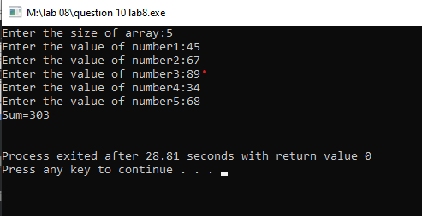

Question 3(code)

#include <iostream>

using namespace std ;

int main ()

{

int av[10]={6,1,2,3,4,6,7,8,9};

int avg;

avg=av[0]+av[1]+av[2]+av[3]+av[4]+av[5]+av[6]+av[7]+av[8]+av[9]/10;

cout<<"Average="<<avg;

return 0;

}

Question 3(output)

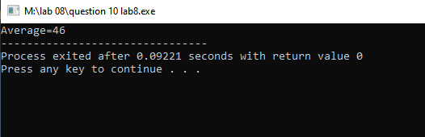

Question 4 (code)

#include <iostream>

using namespace std ;

int main () {

int array1[4]={4,8,12,16};

cout<<"The value in first array are:"<<endl;

for(int i=0; i<4; i++){

cout<<array1[i]<<" ";

}

cout<<endl;

int array2[4];

cout<<"The value in second array are:"<<endl;

for(int j=0; j<4; j++){

array2[j]=array1[j];

cout<<array2[j]<<" ";

}

return 0;

}

Question 4 (output)

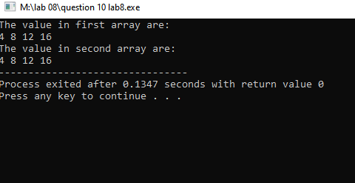

Question 5 (code)

#include <iostream>

using namespace std ;

int main () {

int n;

cout<<"Enter the size of array:";

cin>>n;

int num[n],x;

for(int i=0; i<n; i++){

cout<<"Enter the "<<i+1<<" number:";

cin>>num[i];

}

cout<<"The EVEN numbers are:\n";

for(int j=0; j<n; j++){

if(num[j]%2==0){

cout<<num[j]<<" ";

}

}

return 0;

}

Question 5 (output)

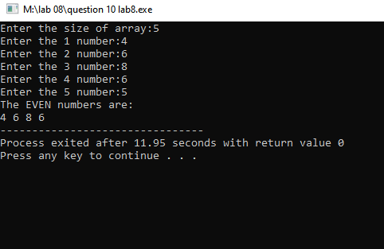

Question 6 (code)

#include <iostream>

using namespace std ;

int main () {

int n;

cout<<"Enter the size of array:";

cin>>n;

int num[n],x;

for(int i=0; i<n; i++){

cout<<"Enter the "<<i+1<<" number:";

cin>>num[i];

}

cout<<"The values on the ODD indices are:\n";

for(int j=0; j<n; j++){

if(j%2!=0){

cout<<num[j]<<" ";

}

}

return 0;

}

Question 6 (output)

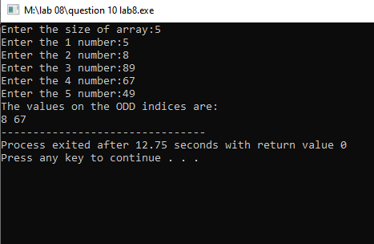

Question 7 (code)

#include <iostream>

using namespace std ;

int main () {

int n;

cout<<"Enter the size of array:";

cin>>n;

int array1[n];

for(int i=0; i<n; i++){

cout<<"Enter the "<<i+1<<" number:";

cin>>array1[i];

}

cout<<"Values of of first array are\n";

for(int j=0; j<n; j++){

cout<<array1[j]<<" ";

}

cout<<endl;

int array2[n];

for(int k=0; k<n; k++){

array2[k]=array1[k];

}

cout<<"Values of second array are\n";

for(int m=n-1; m>=0; m--){

cout<<array2[m]<<" ";

}

return 0;

}

Question 7 (output)

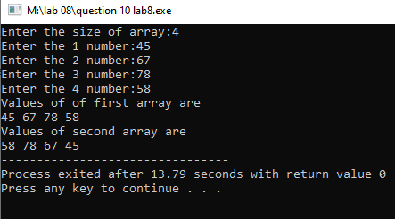

Question 8 (code)

#include <iostream>

using namespace std ;

int main () {

int array1[5]={44,5,30,78,66};

int array2[5]={4,50,60,7,6};

int array3[5];

cout<<"The values of of first array are:\n";

for(int i=0; i<5; i++){

cout<<array1[i]<<" ";

}

cout<<endl;

cout<<"The values of second array are:\n";

for(int j=0; j<5; j++){

cout<<array2[j]<<" ";

}

cout<<endl;

for(int k=0; k<5; k++){

array3[k]=array1[k]+array2[k];

}

cout<<"The values of third array are:\n";

for(int m=0; m<5; m++){

cout<<array3[m]<<" ";

}

return 0;

}

Question 8 (output)

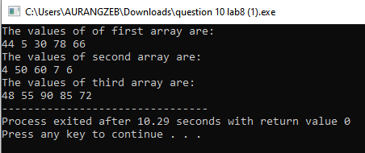

Question 9 (code)

#include <iostream>

using namespace std ;

int main () {

int array1[5]={44,5,30,78,66};

int array2[6]={4,50,60,7,6,76};

int array3[11];

cout<<"The values of of first array are:\n";

for(int i=0; i<5; i++){

cout<<array1[i]<<" ";

}

cout<<endl;

cout<<"The values of second array are:\n";

for(int j=0; j<6; j++){

cout<<array2[j]<<" ";

}

cout<<endl;

for(int k=0; k<5; k++){

array3[k]=array1[k];

}

for(int x=5; x<11; x++){

array3[x]=array2[x-5];

}

cout<<"The values of third array are:\n";

for(int y=0; y<11; y++){

cout<<array3[y]<<" ";

}

return 0;

}

Question 9 (output)

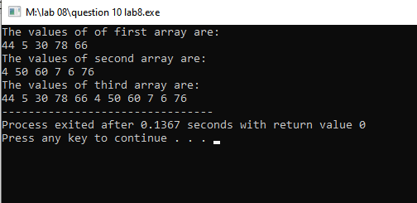

Question 10(code)

#include<iostream>

#include<string>

using namespace std;

int main()

{

int size;

cout<<"Enter the number of students:";

cin>>size;

string name[size];

int pf[size];

double math[size];

double english[size];

double ps[size];

double obtained[size];

double percentage[size];

double grade[size];

for(int i=0; i<size; i++)

{

cout<<"Write name of student"<<i+1<<":";

cin>>name[i];

}

for(int i=0; i<size; i++)

{

cout<<"Write programing marks student"<<i+1<<":";

cin>>pf[i];

}

for(int i=0; i<size; i++)

{

cout<<"Write math marks student"<<i+1<<":";

cin>>math[i];

}

for(int i=0; i<size; i++)

{

cout<<"Write English marks student"<<i+1<<":";

cin>>english[i];

}

for(int i=0; i<size; i++)

{

cout<<"Write P.S marks student"<<i+1<<":";

cin>>ps[i];

}

for(int i=0; i<size; i++)

{

obtained[i]=pf[i]+math[i]+english[i]+ps[i];

}

for(int i=0; i<size; i++)

{

percentage[i]=obtained[i]\*100/400;

}

cout<<"=============================================================================================="<<endl;

cout<<"Name Programming Math English \tP.S \tObtained Percentage Grade"<<endl;

cout<<"=============================================================================================="<<endl;

for(int i=0; i<size; i++)

{

cout<<name[i]<<"\t\t"<<pf[i]<<"\t"<<math[i]<<"\t"<<english[i]<<"\t\t"<<ps[i]<<"\t"<<obtained[i]<<"\t\t"<<percentage[i]<<"\t\t";

if(percentage[i]>=80 && percentage[i]<=100)

cout<<"A"<<endl;

else if(percentage[i]>70 && percentage[i]<=79)

cout<<"B"<<endl;

else if(percentage[i]> 60 && percentage[i]<=69)

cout<<"C"<<endl;

else if(percentage[i]<60)

cout<<"Fail"<<endl;

}

return 0;

}

Question 10 (output)

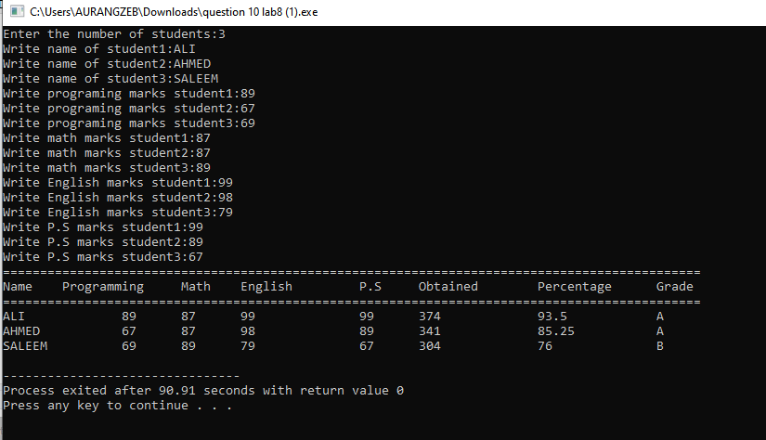

Question 11(code)

#include <iostream>

using namespace std ;

int main () {

int n,smallest(0);

cout<<"Enter the size of array:";

cin>>n;

int array1[n];

for(int i=0; i<n; i++){

cout<<"Enter value number"<<i+1<<":";

cin>>array1[i];

if(i==0){

smallest=array1[i];

}

if(array1[i]<smallest)

smallest=array1[i];

}

cout<<"The smallest value is:"<<smallest<<endl;

return 0;

}

Question 11 (output)

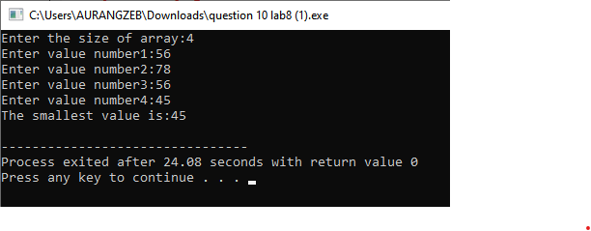

Question 12 (code)

#include <iostream>

using namespace std ;

int main () {

int n,larger(0);

cout<<"Enter the size of array:";

cin>>n;

int array1[n];

for(int i=0; i<n; i++){

cout<<"Enter value number"<<i+1<<":";

cin>>array1[i];

if(i==0){

larger=array1[i];

}

if(array1[i]>larger)

larger=array1[i];

}

cout<<"The largest value is:"<<larger<<endl;

return 0;

}

Question 12 (output)

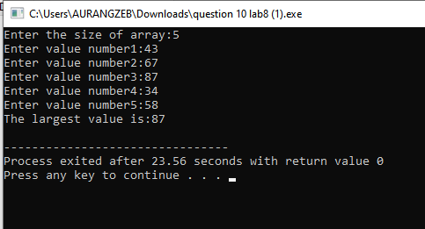

Question 13 (code)

#include <iostream>

using namespace std;

int main()

{

int size,num,value;

cout<<"Enter the size of array"<<endl;

cin>>size;

int search[size];

for(int i=0;i<size;i++)

{

cout<<"Enter the value "<<i+1<<" : ";

cin>>search[i];

}

cout<<"Please Enter the number you want to search : ";

cin>>num;

for(int i=0;i<size;i++)

{

if(search[i]==num)

{

cout<<num<<" is present at "<<i<<" index"<<endl;

value+=1;

}

}

if(value==0)

cout<<"The number you have entered is not available in array"<<endl;

return 0;

}

Question 13(output)

